ATAR Chemistry – Unit 1 & 2

Note:

Use of notes allowed.

Notes must be your own work.

Hand your notes in with this assessment

Research Assignment 3 - Quiz

Fuel Sources

Name:

Notes : ____/ 5 Test Score: /28 Total ____________/ 33

*In answering these questions, do not use exactly the same words as in your research.*

1. Briefly describe how fossil fuels are formed and the timescale it takes? **[3 marks]**

*Deposit of plant matter, animals and micro-organisms, buried under mud, sand and rock* (2)

*The process takes millions of years (1)*

1. Explain one similarity and one difference in the formation process of biofuels and fossil fuels **[2 marks]**

*Similarity -Biofuels are formed from plants and animal waste*

*Difference – biofuels are made from living plants and are converted to fuels by industrial processes (short time scale)*

1. Chemical structure**: [ 4 marks]**
2. Draw the chemical structure of one type of fossil fuel and name it . (2)

*Any organic alkane*

1. Draw the chemical structure of a typical biofuel and name the type of fuel (2)

biodiesel :

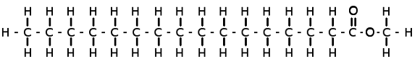

1. With the aid of a **diagram** explain how petrol is obtained from crude oil: [5]

*Fractional distillation, a technique used to separate the components that are relatively close together in boiling point. (1)*

*Mixture is heated and components with different boiling points rise up to different heights. (1)*

*Components with lowest boiling points are collected at the top and highest boiling point at the bottom. (1)*

*Diagram as per textbook*

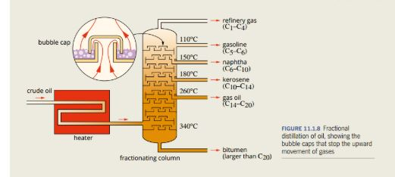(2)

1. Fracking : **(8 marks)**

a) With the aid of a diagram, briefly explain the process of fracking, . (5)

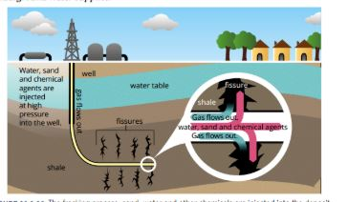

*Diagram (2)*

*A well is drilled through the water aquifer towards trapped gas (1)*

*Chemicals, sand and water are pushed through at high pressure (1) to fracture the rock which releases the gas (1) and is collected through the pipe.*

1. How do oil and gas companies report to protect the water supply (1)

*By encasing the pipe in concrete*

1. Discuss the environmental concerns for this process (2)

*Chemicals and gas could be released into water aquifer, earthquakes*

1. Choose one question to discuss **[ 6 marks]**
2. Discuss whether ethanol is a viable substitute for petrol

OR

1. Discuss whether biodiesel is viable substitute for diesel.

Your answer should include comparison of :

* + energy output
  + Environmental effects and emissions during production.
  + Environmental effects and emissions during use

There should be at least 6 clear points in your discussion, including a summary point.

Could include:

|  |  |  |
| --- | --- | --- |
|  | ***Biofuel*** | ***Petrol*** |
| *Source* | *Renewable +* | *Finite resource* |
| *Production* | *Requires land clearing to plant crops releases CO2(-)*  *However growing the plants reduces CO2 emissions.*  *Production of biofuel uses energy.* |  |
| *Knock protection* | *Better* |  |
| *Stability* | *Biodegradable*  *+ for cleaning up fuel spills*  *- For long term storage* | *Not biodegradable – environmental damage when there are spills* |
| *Use in cold environments* | *Is a polar molecule therefore easier to form crystals and freeze* | *Entire molecule neutral* |
| *Reactivity* | *More likely to react with metals that contain it.* |  |
| *Emissions* | *less sulfur emissions, but more toxic nitric oxide emission for biodiesels- contributes to acid rain* |  |

*Combustion of biofuels: Although burning an alcohol releases less carbon dioxide it also produces less energy so more alcohol is needed to produce the same energy as petrol, overall its results in biofuels emitting more CO2 for the same energy. Similar considerations apply for biodiesel.*

*Taking into account land clearing, growth, production and burning biofuels it is not clear whether biofuels reduce CO2 emission.*